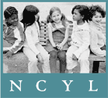
February 21, 2013

Governor Jerry Brown
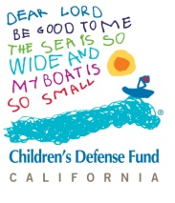
State Capitol
Sacramento, CA 95814

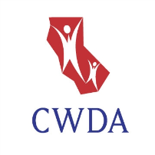
OPPOSITION TO ELIMINATION OF FOSTER YOUTH SERVICES (line item: 6110-119-0001) AND SUPPORT FOR MEANINGFUL INCLUSION IN THE NEW FUNDING FORMULA


The State of California has a unique responsibility to children in foster care. In removing them from their families and homes, the state assumes the responsibilities normally vested in a parent. Unlike any other population of children, the State of California is wholly responsible for their well-being and educational success. In recognition of this responsibility, and in response to the tragically poor educational outcomes of children and youth in foster care, California must prioritize these students.

THE FOSTER YOUTH SERVICES PROGRAM (FYS) MUST BE PRESERVED
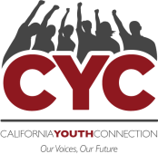
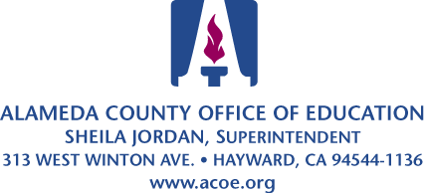
As documented in numerous reports, California’s FYS program has improved the educational outcomes of foster children and serves as a model for other states. The COEs provide the types of educational management, advocacy, transition planning and coordination normally provided by a parent. Foster children are a marginalized, largely invisible, population of students. The loss of FYS will leave tens of thousands of California foster children without anyone assuming the role of parent and supporting their educational success.


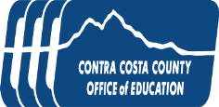
There are also substantial costs associated with eliminating the FYS program. State FYS funds bring California millions of dollars of otherwise unavailable federal funds by serving as a Title IV-E match. Federal laws such as the Fostering Connections Act require child welfare agencies to monitor and track the educational progress of foster children, while recent changes to FERPA further emphasize the need for education and child welfare agencies to work collaboratively to improve the educational outcomes of foster children. The costs of complying with state and federal mandates will increase if, instead of coordinating education services with one county-level education agency, agencies have to work with up to 80 school districts.
LOCAL CONTROL FUNDING FORMULAS MUST ACTUALLY BENEFIT FOSTER YOUTH
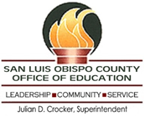
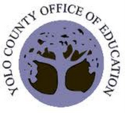
We commend the Governor for recognizing that students in foster care have unique educational needs that require school districts to provide unique educational services. To succeed in school, many children in foster care must overcome trauma suffered as a result of abuse or neglect, removal from home, placement changes, and frequent school changes which often result in gaps in academic learning.

Unfortunately for foster children, under the Governor’s current budget proposal:

- The vast majority of LEAs do not know which of their students are in foster care. Those LEAs that do, depend on the FYS program for this information, which the Governor’s budget eliminates.
- Since every foster child is categorically eligible for the FRLMP, districts will not receive a single additional penny as a result of a student being in foster care.

- LEAs are required to track and report the educational outcomes of EL students and FRLMP students, but are not required to track and report the educational outcomes of students in foster care.

- Under existing law, LEAs are held accountable for the academic performance of EL and FRLMP students. LEAs are not held accountable for the academic performance of students in foster care.


For the reasons listed in this letter, the State should preserve California’s Foster Youth Services program (6110-119-0001) and amend the local control funding formula to ensure that students in foster care are meaningfully included.

Sincerely,
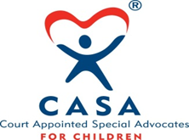

Jesse Hahnel
Director, Foster Youth Education Initiative
National Center for Youth Law
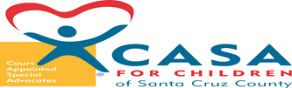
Jamila Iris Edwards
Northern California Director
Children’s Defense Fund

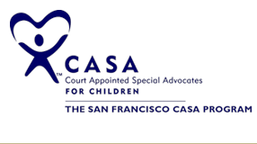
Frank J. Mecca
Executive Director
County Welfare Directors Association of California (CWDA)


Amy Lemley
Policy Director
John Burton Foundation

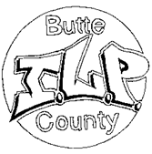
Crystal O'Grady
Policy Coordinator
California Youth Connection

Sheila Jordan

Superintendent
Alameda County Superintendent of Schools

Alameda County Office of Education

Catherine Giacalone
Youth Development Services Manager
Contra Costa County Office of Education

Michael Watkins
Superintendent of Schools
Santa Cruz County Office of Education

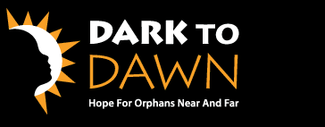
Jessica Thomas Senior Program Coordinator
San Luis Obispo County Office of Education

Jorge Ayala
Superintendent
Yolo County Office of Education

Eleanor Averitt
Program Assistant, Foster Youth Service
Elk Grove Unified School District

James C. Wogan, LCSW, PPSC
Administrator, School Linked Services
Mt. Diablo Unified School District
Foster Youth Services

Murry Schekman
Assistant Superintendent
Pajaro Valley Unified School District

Carol Ann Franklin, Ed.D. Professor Emerita
Partnership for Youth in Foster Care, Director
San Bernardino County Superintendent of Schools
Foster Youth Services
University of Redlands, School of Ed.

Kara Hunter
Executive Director
Court Appointed Special Advocates of San Bernardino County

Cynthia Druley
Executive Director
Court Appointed Special Advocates of Santa Cruz County

Jeff Perry
Educational Advocacy Coordinator
Court Appointed Special Advocates of San Francisco

Reed Connell
Executive Director
Alameda County Foster Youth Alliance

Tami Thompson
Butte County ILP Coordinator

Butte ILP County

Tracy Tousley, MA
Executive Director / Founder
California Foster Families, Inc.

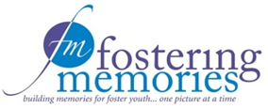
Melanie Delgado
Staff Attorney
Children’s Advocacy Institute

Todd Heie
Chief Probation Officer

County of Siskiyou Probation Department

Joy Biddle
Executive Director
Creative Alternatives, Inc.

John Franklin
Director, Foster Care Ministry
Dawn to Dark

Roger Chan
Executive Director

East Bay Children’s Law Offices

Lisa L. Russell, M.A.
Executive Director
Educational Tutorial Services

Tiffany McGee

Social Worker
Environmental Alternatives

Laurie Campbell
Executive Director
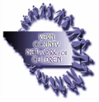
Fostering Memories

Anne Ratto
Associate Dean, EOPS/CalWORKs
Gavilan College
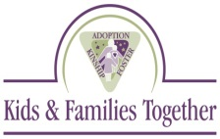
Rhonda Leiva
Assistant Director
Guardian Scholars at San Jose State University


Richard Puente
Program Coordinator
Healthy Start Program

Joe Costa
CEO
Hillsides

Tom Corson
Executive Director
Kern County Network for Children

David Friedlander
President/CEO
Kids & Families Together

Bryan Lowery
Assistant Director
Mendocino County Health and Human Services Agency (HHSA)

Ralph Ward
Executive Director
Northern California Youth and Family Programs

Cal Winslow
CEO
Orangewood Children’s Foundation

Steve Duran
Director of Programs
Peacock Acres, Inc.

Tonya L. Torosian, MSW, CFRE
Chief Executive Officer
Promises2Kids

Martha Matthews
Directing Attorney, Children's Rights Project
Public Counsel Law Center

Camille Schraeder
Executive Director
Redwood Children’s Services, Inc.

Pamela Hansen, LCSW
Director of Program Development
San Diego Center for Children


Matt Martin

Executive Director
Social Advocates for Youth

James B. Pace, Ph.D.
Executive Director

Starshine Treatment Center

Patricia L. Boles
Executive Director
Straight From The Heart, Inc.
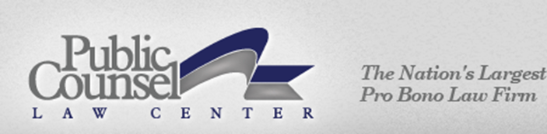
Pam Dyer
Executive Director
Sylvan Learning Center

Lisa Castetter
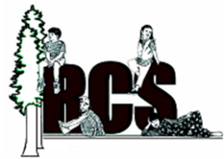
Founder and CEO
Teen Leadership Foundation

Sharon M. Lawrence
President/CEO
Voices for Children, Inc.

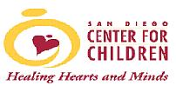
Also including the following organizations as well as hundreds of California voters:

Alameda County Foster Youth Alliance
Alameda County Office of Education
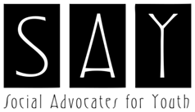
Butte County ILP
California Foster Families, Inc.
California Youth Connection
CASA of San Bernardino County
CASA of Santa Cruz County

CASA of San Francisco County
Children’s Defense Fund
Child Welfare Directors Association of California (CWDA)
Children’s Advocacy Institute
Contra Costa County Office of Education

County of Siskiyou Probation Department
Creative Alternatives, Inc.
Dark to Dawn
East Bay Children’s Law Offices
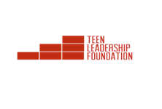
Educational tutorial Services
Elk Grove SUD
Environmental Alternatives
Fostering Memories
Gavilan College

Guardian Scholars at San Jose State University

Healthy Start Program
Hillsides
John Burton Foundation
Kern County Network for Children
Kids & Families Together
Mendocino County H.H.S.A.
Mt. Diablo USD Foster Youth Services
National Center for Youth Law
Northern California Youth and Family Programs
Orangewood Children’s Foundation
Pajaro Valley USD
Peacock Acres, Inc.
Promises2Kids
Public Counsel Law Center
Redwood Children’s Services, Inc.
San Bernardino County Superintendent of Schools FYS University of Redlands
San Diego Center for Children
San Luis Obispo County Office of Education
Santa Cruz County Office of Education
Social Advocates for Youth
Starshine Treatment Center
Straight From The Heart, Inc.
Sylvan Learning Center
Teen Leadership Foundation
Voices for Children, Inc.
Yolo County Office of Education

